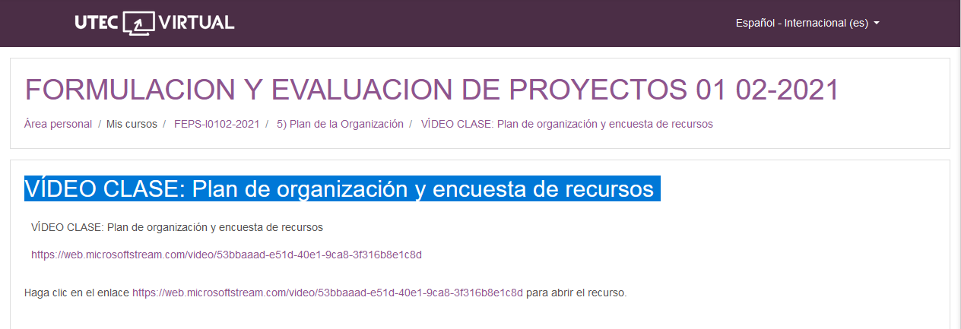

<https://web.microsoftstream.com/video/53bbaaad-e51d-40e1-9ca8-3f316b8e1c8d>